GENERAL AGREEMENT FOR
COMMERCIAL ANNOUNCEMENTS (CANADA)

BETWEEN

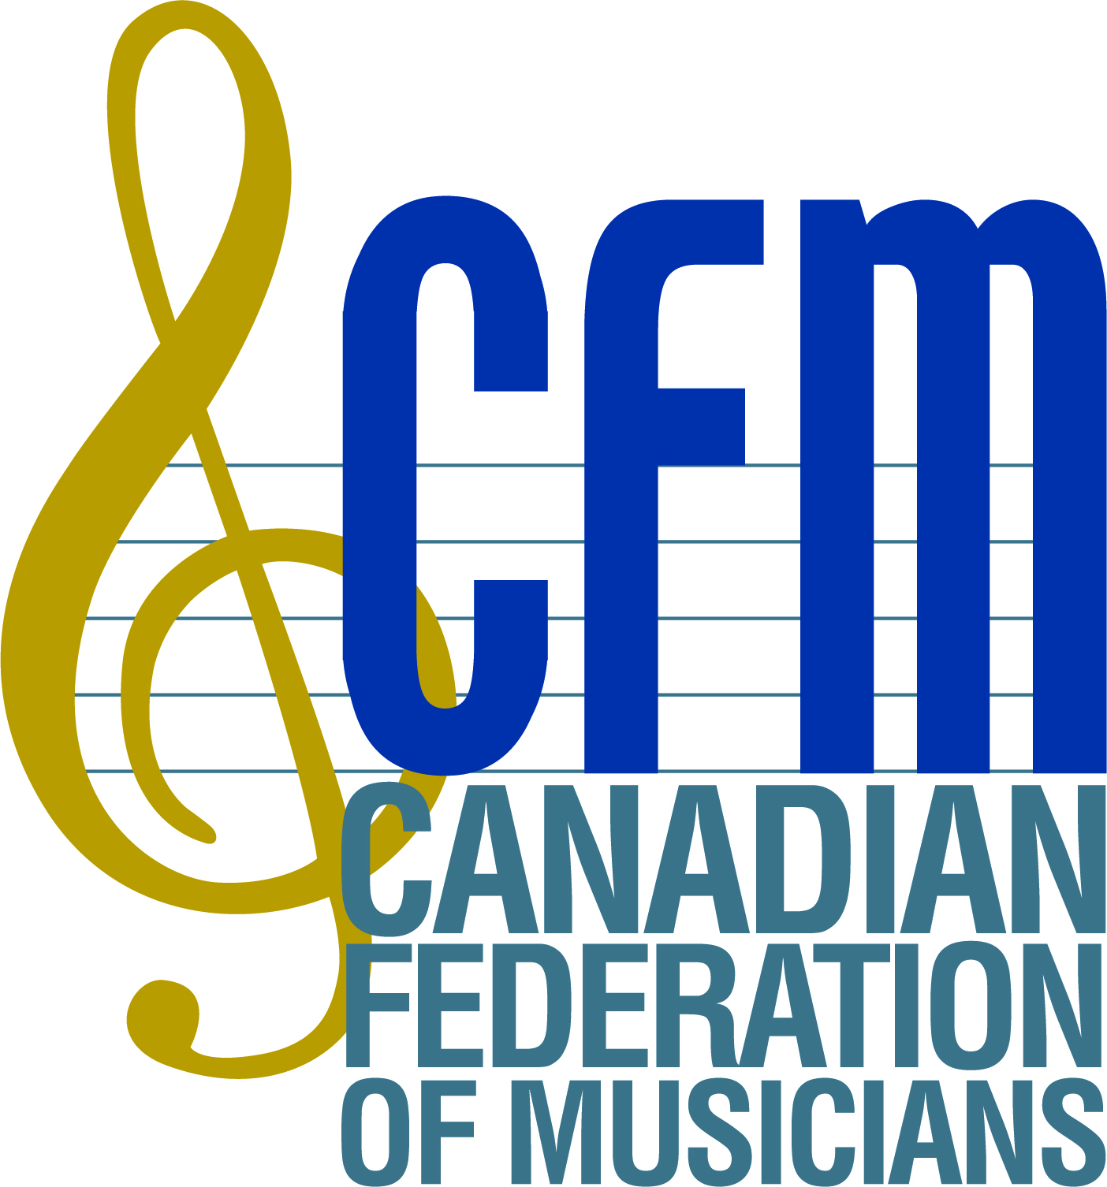

AND

April 1, 2015 – March 31, 2020

GENERAL AGREEMENT FOR COMMERICAL ANNOUNCEMENTS (CANADA)

Index

Article Page

A
AFM Bylaws …………………………………………….21F…………..23
Arranger …………………………………………………5C…………...10
Assumption Agreement ……………………………….. 21B(2) ……….22

B
Basic Statement of Contractual Agreement …….............. 1 6

C
Campaign …………………………………………….. 5N …………11
Canadian Agreement …………………………………... 2 6
Canadian Employment ……………………………… 21C 23
Cancellation …………………………………………… 7H 13
Cartage ……………………………………………… 7F 13
CFM Approval ……………………………… 21B(1)……….22 CFM as Bargaining Agent (Recognition of)…………… 4A .7
CFM, Obligation of/AFM Bylaw Recognition ……… 3 …………….6
CFM Permission ………………………………… 8B 14
CFM or Local Representatives ………………………. 21E …….…..23
Code for ReUse Reporting………………………………4E…………..8
Commercial Announcement …………………………… 5F ………… 11
Commercials Made in Canada …………………….… 4B……………7
Commercials Made for Digital Media……………………17…………...18 Commercials Not Used For Two Years ……………….. 10F 16
Commercials Produced for Specialty Pay-TV
Commercials Produced/Used, Non-Broadcast Media ….13 …………..17
Contract ……………………………………………….. 5H ……… 11
Contract Service Fee …………………………………... 7D 13
Contractor……………………………………………….5A………….10
Contrary to Agreement (Nothing)……………………... 6A 12
Copyist…………………………………………………. 5E ………. 11
Copy of Payment Authorization ……………………… 4D(8)……… 10
Cycle ………………………………………………….. 5I ………… 11

D
Dealer Tags …………………………………………… 10J 17
Demo Fees ……………………………………………. 11 17

Digital Media ………………………………………… 5O ………….12
Digital Media (Internet) ……………………………..… 17 …………..18
Doubling ……………………………………………… 7E ………….13
Dubbing ……………………………………………… 10B ………...15
Dubbing (Definition)………. …………………………... 5K 11
Dubbing Sessions (Notice of)…………………………...4D(6) ………10

E
Editing ……………………………………………… 8…. 14
Electronic Musical Devices [EMD’s].(Multiple Parts and)..7E 13
Extraordinary Circumstance ……………………………. 16 …………18

F
Federation By-laws ……………………………………. 21F 23
Fees/Rate Chart …………………………………...“Appendix 1” ...26-28
First Use (Notice of)…………………………………… 4D(7) …… 10 Foreign Use …………………………………………… 15 …………. 18
Forty-Five Day Short Life ……………………………….10H ……… 16

G
General Conditions ……………………………………. 21 22
Glossary of Terms……………………………………..5A-O……….10-12
Grievance and Arbitration ……………………………... 23 24
Guaranteed Length of Call …………………………….. 7A 12

I
Individual Contracts ………………………………… 6 12
Information, Announcements and/or Contracts
(Survival Clause) ………………………………………. 4D(5) …….....9
Initial Use …………………………………………….... 10A 14
Internet (see Digital Media)…...…………... 17………………………. 18

J
Joint Committee ………………………………………. 24 25

L
Late Payment Penalty ………………………………….. 20B ……….. 21 Law and Language Translation (changes required by law) 9 .14
Leader ………………………………………………… 5B …………. 10
Leader, Contractor, Arranger, Orchestrator Paid Double .. 7B .13
Limitation on Use ……………………………………... 8A .14
List of Announcements ………………………………... 4D(4) ……….9
Local Fees and Conditions …………………………….. 12 17

M
Mechanical Editing (see Version)…………………………………5G 11
Minimum Call Sessions ………………………………... 7A 12
Minimum Fees ………………………………………… 4C 7
Multiple Parts and Electronic Musical Devices (EMD’s). 7E 13
Musicians Pension Fund Canada (MPF Canada) ……… 19 21

N
National Commercials ………………………………… 10C(1) ……. 15
National Recording Fees and Working Conditions
For Musicians, Leaders and Contractors ………………. 7 12
National Short-Life and Promotional Commercials …… 10H 16
National Short-Life Commercials …………………… 10H 16
National Short-Life Fees ………………………………. 10H 16
National Use Fees ……………………………………... 10H 16
New Use ………………………………………………. 5L ………… 11
New Use Fees …………………………………………. 18 …………. 19
New Use Reports …………………………………… 4D(3) ……….9 Non-Broadcast Media (Commercials Produced or Used in)13 17
Non-Continuous Overtime …………………….“Appendix 1” ………26
Non-Discrimination ………………………………… 21D 23
Notice of Dubbing Session ………………………….. 4D(6)……….10
Notice of First Use ………………………………….. 4D(7) 10
Nothing Contrary to Agreement……………………... 6A 12

O
Obligations of Producer ……………………………….. 4 7
Orchestrator ………………………………………… 5D ………… 11
Overtime ………………………………………… “Appendix 1”…… 26

P
Payment Authorization (Copy of)……………………... 4D(8) 10
Payment Information ………………………………….. 20C 22
Payments ……………………………………………… 20 20
Pension [Musicians Pension Fund Canada]……………...19 21
Place and Time ………………………………………... 20A 21
Premium Rates ……………………………………… 7G 13
Prepayment for One Year …………………………….. 10D 16
Prepayment One Year Single Advertiser/Brand,
Unlimited Commercials ………………………………. 10E ……….. 16
Public Service Commercials …………………………… 10G 16

R
Rates and Conditions, Applicability of ………………… 4C ...7
Reuse ………………………………………………… 5M 11
Reuse Fees …………………………………………… 10C 15

Reuse Reports ………………………………………… 4D(2) …..…. 8 Regional Commercials (fees & conditions) ……………..12…………..17
Regional Commercial Reuse …………………………… 10C(2) ..…... 16
Reporting …………………………………………… 4D 8
Required Roles ………………………………………… 7A ……….. 12

S
Scale …………………………………………………… 5J ………… 11
Sideline Musicians …………………………………… 22 …………. 24
Signature Page/Negotiating Parties…………………………………….30
Single Musicians ……………………………………… 7C 13
Stings ………………………………………………… 14 18
Stock Music Fee………………………………………..4D(4)………….9

T
Term of Agreement …………………………………… 25 25
Time (Place & Time) ………...…………………20A(2) 21
Transfer of Rights …………………………………….. 21B ………..22
Tri-Party Assumption Agreement……............................... “Exhibit C” 30

U
Unlimited Use ……….…………….. 10E 16

W
Waivers ………………………………………………... 21G 23
Wild Tracks (No)……………………………………… 21A 22

V
Version ………………………………………………….. 5G 11

GENERAL AGREEMENT FOR COMMERICAL ANNOUNCEMENTS (CANADA)

(Apri1 1, 2015 – March 31, 2020)

Canadian Federation of Musicians 150 Ferrand Drive Suite 202, Toronto, Ontario
M3C 3E5

BASIC STATEMENT OF CONTRACTUAL AGREEMENT

In consideration of the mutual covenant herein contained and of other good and valuable considerations, the Canadian Federation of Musicians (herein called the “CFM”), agrees with the Producer upon the terms, conditions, provisions and covenants in the paragraphs below. The Canadian Federation of Musicians (CFM) is the operating name in Canada for the American Federation of Musicians of the United States and Canada (AFM). While referenced as either or both herein, they are the same entity for the purposes of this Agreement.

This Agreement relates only to the engagement of person(s) in classifications covered by this Agreement (herein called “musicians”) in connection with the making of recorded media commercial announcements.

A commercial announcement consists of words accompanying music, or of words under or over the music, or of music intended to be performed without words (not including theme music for a programme).

CANADIAN AGREEMENT

This Agreement applies to commercial announcements produced and recorded in Canada by members of Canadian Locals of the American Federation of Musicians of the United States and Canada (AFM). It being further clarified that bona fide member(s) of AFM, are also eligible to be engaged hereunder, provided a work authorization is granted to said member(s) in conformity with the requirements/rules of Immigration Canada.

OBLIGATION OF CFM & AFM BYLAW RECOGNITION

The CFM/AFM shall exercise full authority in order that it’s Locals and members shall do nothing in derogation of the terms and intent of this Agreement. In this regard, the parties hereto agree, that all present provisions of the Bylaws, rules and regulations of the AFM, and all present Bylaws, rules and regulations of the Local in whose jurisdiction the musicians perform, insofar as the foregoing do not conflict with any of the provisions of this Commercial Announcements Musicians’ Recording Agreement for Canada, are made part of this Agreement. For greater certainty, and in the event any such conflict should occur, the provisions of this Agreement shall prevail. It is understood that the provisions contained in AFM Bylaws and/or Local constitutions/Bylaws are not subject to the grievance procedure detailed under Section 20.

OBLIGATIONS OF THE PRODUCER

  - Recognition of CFM as Bargaining Agent

The Producer hereby recognizes the CFM, in respect of the varied and skilled disciplines covered by this Agreement, in addition to the Federal certification of the CFM under Federal Status of the Artists, as the exclusive bargaining representative of AFM/CFM members engaged by the Producer who provided professional services as instrumental musicians, orchestrators, arrangers, music proofreaders and librarians, copyists, sideline musicians, and members performing a musical service on any electronic device in connection with the making of commercial announcements.

Commercials Made in Canada

For commercials produced in Canada, which require music that is specifically composed and/or arranged for said commercial(s), or which require the disciplines stipulated under clause 4, A. above, the Producer shall only engage members of AFM/CFM Locals to render these professional services. For further clarity, the Producer agrees not to record music outside of Canada, wherein the primary purpose is to avoid engaging member musicians as provided hereunder.

Applicability of Rates (Minimum Fees) and Conditions

For the professional services rendered hereunder, the Producer shall pay no less than the minimum (scale) fees prescribed hereunder and shall fully observe and faithfully perform all other terms and conditions set forth herein, which by reference, are made part and parcel of any individual agreements with the AFM Local member(s) engaged hereunder.

Reporting

    - Filing of Contracts
Regarding any commercial to be produced hereunder, the signatory/Producer shall, within ten (10) business days after the time of the original recording session, provide to the Local a Form B contract containing the following information:

      - Name of the Leader and/or contractor, if applicable;
      - Name of the advertiser;
      - Name of the commercial(s) and product(s) being advertised;
      - Length of the music track(s) for each commercial and each version;
      - AFM Form B contract reference number(s) intended to be used for the original session;
      - Type of commercial(s) and the intended media use(s); i.e. national, regional, local, demo, public service, etc., television, radio, digital media.
      - Commercial announcement code for reuse reporting:
(C) beside the title of each individual commercial announcement
(V) beside the title of each version or edit of an individual commercial announcement

NOTE: If there are multiple commercial announcements on the contract (as there can be up to three (3) individual commercials on an original contract for a piece of music - spots & versions / edits should be denoted in the following manner:

Announcement 1: (C-A) - TITLE
Followed by its versions denoted as: (V-A) - Title

Announcement 2: (C-B) - Title
Followed by its versions denoted as (V-B) Title

Announcement 3: (C-C) - Title
Followed by its versions denoted as (V-C) Title

    - Reuse Reports and Additional Use Reports
Within fifteen (15) days following the commencement of any reuse cycle of a commercial announcement, the Producer shall provide to the Local a Form B contract containing the following information:

      - Name of the Leader and/or contractor, if applicable;
      - Name of the advertiser;
      - Name of the commercial(s) and product(s) being advertised;
      - Length of the music track(s) for each commercial and each version reused;
      - AFM Form B contract reference number(s) intended to be used for the reuse as well as the original Form B contract reference number.

    - New Use Reports
Within fifteen (15) days following the commencement of any use of a commercial announcement Producer shall report the following information to the Local in whose jurisdiction the recording session took place, or elsewhere if requested by the AFM/CFM: title of the commercial announcement, advertiser for whom made, product advertised, date of the recording or dubbing session, broadcast media for which originally made, additional broadcast media in which such different use has commenced, and date upon which such use has commenced. Such report shall be made either in form of a copy of a Form B contract or otherwise. The aforesaid provisions shall also apply when a commercial announcement is used in foreign countries.

    - List of Announcements -Reporting and Payment of Stock Music Fee
Following the execution of this Agreement, the Producer shall furnish to the CFM and the CFM Local where they are based, on the first business day following 15th of every month, a list of all commercial announcements produced for the previous month. For every commercial announcement produced the list shall indicate the advertiser, the title of the announcement, the medium where the announcement was first broadcast (Radio, TV, Internet, or Other) and whether the commercial was produced hereunder and/or whether commercial sound recording(s) were utilized and/or whether stock music was utilized.

Along with the report, the Producer shall remit to the CFM a payment of $30 for each instance of stock/library music used in the production of a commercial campaign. Late payments are subject to the same penalties as for an original session, as prescribed elsewhere in this Agreement.

The CFM shall allocate 50% of the amount collected to the Musicians’ Pension Fund of Canada, and 50% to the CFM New Use account.

Each report received by CFM will be forwarded to the ICA/ACA and made available to any Local upon request within twenty (20) business days of receipt.

    - Information, Announcements and/or Contracts (Survival Clause)
The Producer shall respond promptly to requests by the CFM for information relating to the Producer’s performance of the terms, conditions and covenants of this Agreement and of any individual agreement with a person covered by this Agreement. Upon request by the CFM, the Producer shall promptly furnish a copy of any commercial announcements owned, produced, distributed, used, or the use of which has been permitted by the Producer, and if the right to do so has been purchased or otherwise acquired by the Producer, a copy of the contract under which such right was acquired. The Producer shall also furnish, upon request by the CFM, copies of any contract of sale, rental or other distribution or from contract of sale, rental or other distributions covering any of such commercial announcements. The provision of this paragraph shall survive this Agreement.

    - Notice of Dubbing Sessions
The Producer shall advise the applicable Local or the CFM, whenever a music track covered by this Agreement has been dubbed into a new commercial. Such advice shall include the information specified in three (3) above.

    - Notice of First Use
The Producer shall advise the applicable Local or CFM, of the first air date of each commercial covered by this Agreement if such information has not been included on the Form B contract filed for the session, dubbing or new-use.

    - Copy of Payment Authorization
Whenever the Producer authorizes another organization or company to pay musicians for reuse, dubbing or New Use, and whenever such authorization is in writing, the Producer will send a copy thereof to the applicable Local at the same time it sends such authorization to the organization or company.

GLOSSARY OF TERMS

Contractor: The contractor shall be defined as the person who is responsible for the accurate execution of the music session and the Form B contract including all musicians, overdubs, cartage, overtime etc.

Leader: The Leader shall be defined as the person who assigns parts to the musicians and supervises the session recording. The Leader is responsible to receiving all session and residual payments and distributing the appropriate payments to the musicians who performed on the original contract as well as remitting appropriate pension contributions and contract services fees.

Arranger: The Arranger organizes a previously written composition for presentation in other than its original form. An arrangement shall include re-harmonization, paraphrasing and/or development of a composition so that it fully represents the melodic, harmonic and rhythmic structures and is in complete score form, whether completed using computerized or non-computerized methods.

Orchestrator: Orchestrators are responsible for the scoring of the various voices and/or instruments of an arrangement without changing or adding to the melodies, counter-melodies, harmonies and rhythms.

Copyist: A Copyist transcribes the musical parts from a score, or copies any other materials required in the production of the score, whether by hand or electronic means.

Commercial Announcement: A commercial is an audio or audio/visual advertisement that depicts or mentions a sponsor’s name, product or service, may include a call to action, and is no longer than three minutes.

Version: A commercial may be edited to create different versions of that commercial. The new version must retain a portion of the original commercial from which it was derived.

Original Contract: The original contract details the commercial announcement(s) in a session and all versions of those announcements.

Cycle: The length of time the commercial announcement may be broadcast given the fees paid and conditions of the agreement.

Scale: The base fee for one music service according to the type of contract, also referred to commonly as “unit”, to which all premiums and multipliers shall apply.

Dubbing: Dubbing refers to the transfer of a music track into one or more commercials in the same broadcast medium for a single advertiser). Dubbing fees are based on current rates.

New Use: Refers to the transfer of a music track into one or more commercials in a different broadcast medium (e.g.: radio track used on a TV commercial). New use fees are based on current rates.

Reuse: Reuse refers to an additional broadcast cycle after the conclusion of the first declared cycle of use (where there are no audio or video changes to the commercial). Cycles need not be consecutive, but must commence before dormancy applies (two years from either the original session date or from the end of the previous cycle).

Campaign: A campaign is defined as series of commercial announcements with a single theme to promote a particular product or brand.

Digital Media: This applies to all commercials made for or designed for exhibited on Digital Media, defined as digital, electronic, or any other type of delivery platform including, but not limited to, commercials delivered via Internet podcasts, mobile phones, and other digital electronic media. The term Digital Media is intended to be all-inclusive of digital, electronic or any other type of delivery platform, whether now known or unknown.

INDIVIDUAL CONTRACTS
The Producer shall enter into individual contracts with persons in classifications covered by this Agreement, and such contracts shall be on the blank forms not in conflict with this Agreement authorized from time to time by the CFM. No person shall be placed on a Form B contract unless the person actually performs a musical service covered by this Agreement and that Form B contract.

Nothing Contrary to Agreement

The Producer shall not require, request, induce, or in any manner attempt to influence any person in a classification covered by this Agreement to play, perform, or render services in a manner contrary to this Agreement.

Single Advertiser, Single Campaign

Only commercial announcements advertising the products of a single advertiser may be made during any one session and the overtime related thereto.

NATIONAL RECORDING FEES AND WORKING CONDITIONS FOR MUSICIANS, LEADERS AND CONTRACTORS

Instrumentalists, Leaders and contractors shall be paid not less than the fees set forth below and the conditions set forth shall apply.

Minimum Call Session and Allowance
There shall be a minimum call session of one (1) hour during which up to three (3) commercial announcements, derived from a single composition may be recorded for a single advertiser. Never shall the total length of commercial announcements and versions, which utilize the music recorded in one session, exceed three (3) minutes in the aggregate. If so, an additional session must be called and an additional original contract must be created.

Required Roles
There must be a Contractor, Leader and at least one (1) performing musician on all commercial announcement contracts, and an Arranger, Orchestrator and Copyist, as determined by the Leader.

Leaders, Contractors, Arrangers, and Orchestrators Paid Double
The minimum fee, per session, for Leaders and Contractors shall be double the minimum fee applicable to the musicians engaged on the session. The Leader cannot perform the services of a Contractor, and receive payment for both services.

Single Musicians
If only one (1) person actually performs, aside from the Contractor and Leader, the performer shall be paid double the minimum fee applicable.

Contract Service Fee
A contract service fee of one-hundred dollars ($100.00) shall be paid by the Producer, and made payable to the Local in whose jurisdiction the original recording took place. This fee is payable, and shall be included with the filing of each ORIGINAL contract. Fifty percent (50%) of the total service fee collected by the CFM/AFM Local shall be remitted to I.C.A. and A.C.A. (twenty-five percent [25%] each) on a quarterly basis, through the CFM national office.

Multiple Parts and Electronic Musical Devices [EMD’s]
If a musician performs multiple instrument parts, often but not exclusively pertaining to the use of Electronic Musical Devices, he/she shall be paid the total of all payments which would otherwise have been payable had a separate musician been used for the parts as determined by the Leader.

Cartage
Whenever a musician is required to bring a heavy instrument to an engagement, the Producer will pay public carrier cartage bills as submitted. If private transportation is used, the Producer will pay musician cartage fees up to a maximum of $100.00.

Premium Rates
All work performed between midnight and 8:00 a.m., on Sundays, and on the following holidays shall be paid for at two (2) times basic scale: New Year’s Day, Family Day, Good Friday, Victoria Day, St. Jean Baptiste, Canada Day, Labour Day, Thanksgiving Day, and Christmas Day, and Boxing Day. With respect to the above, holidays will be observed on the date recommended by the Government of Canada.

Cancellation
A session, once called, must be cancelled within 48 hours or is subject to full payment. Postponement made with less than 24 notice hours must be paid in full.

EDITING

Limitation on Use

A sound track or recording made hereunder shall not be used or dealt with for any purpose whatsoever except to accompany or to be part of the commercial announcement(s) and or version(s) for which such sound track or recording was contracted for as per the rules of this agreement.

CFM Permission
The announcer(s) copy and/or singer(s) which accompany or are under or over the music of a sound track shall not thereafter be altered, nor shall any words be added after the music is recorded other than to create another commercial announcement or version, and used as per permissible in this agreement.

LAW AND LANGUAGE TRANSLATION (changes required by law)

The following alterations may be made in a commercial announcement without changing it into a new or additional commercial for the purpose of this Agreement:

- The on and/or off camera message of a commercial announcement made for a designated advertiser and/or product shots contained therein may be varied (but only to the extent necessary) to comply with legal, language requirements, government regulations, or specific media requirements.

- The off camera message of a commercial announcement or any words shown in a commercial announcement may be recorded or translated in Canada in two (2) languages. Said commercial may be translated into multiple languages beyond two (2) for the additional payment of 50% of the session fee.

In Reuse cycles – An additional payment of 50% of the session fee covers all multiple languages on the original contract beyond the original two allowable languages.

NATIONAL TELEVISION AND RADIO USE TERMS

  - Initial Use

- For the initial payments set forth in this Agreement, up to (3) commercial announcements recorded at any one session may be broadcast either by television stations or by radio stations, but not by both, during a period of thirteen (13) weeks (“initial cycle”), from the date of the first broadcast.

- Up to three (3) commercial announcements, and up to six (6) versions of those announcements, for a single advertiser, totaling up to three (3) minutes may be recorded in the original session and must be broadcast for the first time within nine (9) months following the session.

- Additional commercial announcements beyond (3) three, additional versions beyond six (6) or an aggregate time of commercial announcements and their versions beyond three (3) minutes, shall be paid on a new contract at full fees.

- Seasonal commercials may be recorded and will include but are not limited to advertising messages for Christmas, Valentine’s Day, Family Day Easter, Mother’s Day, Father’s Day, Canada Day, Thanksgiving Day and Halloween. For these seasonal commercials the period shall be twelve (12) months. Commercials not broadcast within the time frame of this paragraph are considered dormant.

Dubbing
Each time a single music sound track which was originally recorded for one or more commercials is:

1. incorporated into additional commercials for the same product used in the same medium, which commercials exceed the number included on the Form B contract filed for the original session, or

2. included on the Form B contract filed for the session but the announcer copy is not added until more than ten (10) weeks after the recording session, then a reuse fee shall be paid per commercial dubbed.

Reuse Fees
The initial broadcast cycle is 13 weeks, as are subsequent broadcast cycles. The first broadcast in such broadcast media following any thirteen (13) week cycle shall start a new thirteen (13) week cycle. The end of one (1) thirteen (13) week cycle and the commencement of the next such cycle need not be contiguous.

- National Commercials
For each commercial announcement (including any of its versions) from an original contract that is used beyond the initial thirteen (13) week cycle, for each additional thirteen (13) week cycle, the producer shall pay fifty percent (50%) of the musician’s scale wages for all services on the original contract PER individual commercial announcement (the versions /edits of each commercial announcement are covered under that fee). For each such additional thirteen (13) week cycle, the same reuse fees shall apply.

- Regional Commercials (ReUse)
A regional commercial may be reused as a national commercial provided that a step-up fee from regional to national is paid, within the original cycle. A national commercial may be reused as a regional commercial provided fifty (50) percent of the regional fee is paid to all musicians who performed a service under the original contract.

Prepayment for One Year
A broadcast commercial may be produced and utilized on National TV or Radio, but not both, for one (1) year provided that a full session payment plus three (3) reuse payments (three (3) cycles) is made, with that total is discounted by fifteen percent (15%). Prepayment must be declared at the time of the original recording session. Reuse for an additional year(s) shall be one hundred percent (100%) of the original payment.

Prepayment for One Year, Single Advertiser, Single Brand, Unlimited Commercial Announcements

Unlimited commercial announcements may be made for a single advertiser, for a single brand, in a single session for use on National TV or Radio, but not both, if it is so designated in advance on the contract and advanced payment is made at five hundred percent (500%) of the basic fee for all services performed on the contract. Subsequent one (1) year cycles shall be payable in advance at the same fee.

Commercial Not Used For Two Years
If any commercial, after its’ initial use is not utilized for two (2) years, the first thirteen (13) week cycle of use thereafter must be paid at the full applicable one (1) hour session fee rate provided for in the CFM Commercials Contract which is in effect at the time reuse is activated. Subsequent thirteen (13) week cycles must be paid at the reuse rate which is in effect at the time reuse is activated.

Public Service Commercials
Public Service Commercials which includes recognized charities may be produced provided the original session fee is paid to all members providing a service on the commercial. Reuse payments may be waived with the permission of the Vice-President from Canada, or his designee, prior to the session and provided that all musicians are notified when engaged for the session.

Forty Five (45) Day Short Life
The commercial announcements and versions from an original sensation may be used for a single forty-five (45) day period, instead of the regular cycle at the discounted rate of 20% off the national fee. Any subsequent cycles must be paid as if the original cycle was 13-weeks.

Dealer Tags
When edited, dealer tags will not be considered as versions, and may be made without additional fee while a commercial is in cycle.

A single National commercial may be produced and edited to permit Local dealer advertising copy and visual information to be included in the national commercial at no additional cost, provided the original commercial is in cycle.

- DEMO FEES
The demo musicians for a campaign will not go on the original contract unless they record the music that is chosen for a commercial announcement on that contract. Instead, for each audio production budget whereby original music is quoted - a flat fee of 250.00 will also be included in the budget as a pension contribution for the musicians who demo original music for the campaign. The fee will be billed to the producer by the leader. It will be the responsibility of the leader to submit and report said pension contribution to the local CFM office on a monthly basis, including the accompanying demo musicians(s) information and SIN. Monthly demo pension contributions may be combined into a single monthly report.

REGIONAL COMMERCIALS

Terms and conditions of the National contract shall apply to regional commercials with the exception that use fees include 26 weeks.
All advertisers may use the fees and conditions as outlined, but the commercials are restricted to use in the following areas:

- Territories
- Maritimes and Newfoundland
- Province of Québec (excluding Montreal)
- Province of Ontario (excluding Toronto)
- Prairie Provinces
- British Columbia (excluding Vancouver)

If a commercial is used in more than one region as outlined above the national fees and conditions apply.

COMMERCIALS PRODUCED OR USED IN NON-BROADCAST MEDIA (e.g. CNE, Royal Winter Fair, PNE, test-mobiles, theatres, stadiums, in-flight, etc.)

A National Commercial, while in cycle, may be utilized in non-broadcast media, at no additional fee. If used outside the broadcast cycle, one National Reuse fee will apply, however the term is 26 weeks. For commercial announcements made for non-broadcast media, national recording fees and working conditions shall apply and paid in twenty six (26) week cycles.

STINGS

  - One (1) hour session – single advertiser – one (1) sting - maximum five (5) seconds.
  - Inserted at beginning or end (not in body) of other commercial for the same advertiser.
  - Unlimited inserts (for same advertiser) for one (1) year from first broadcast – National Fees plus an additional one hundred and fifty percent (150%).

FOREIGN USE

Use of any commercial announcement in a broadcast media outside of Canada or the United States, its territories and possessions, shall require an additional fee.

Formula:
- 18 months use.
- Unlimited language changes per Continent.
- Fees:
- Europe - additional 100% of original fee.
- All others – additional 50% of original fee per continent.
- World use - (pre-paid) additional 250% of original fees.

EXTRAORDINARY CIRCUMSTANCES

Any extraordinary circumstances and/or situations not covered by this Agreement may be discussed and resolved by the Producer and the office of the Vice- President from Canada. If necessary, representation from The Institute of Communications Agencies and The Association of Canadian Advertisers will become involved with the resolution of the matter.

DIGITAL MEDIA (INTERNET)

This section applies to all commercials made for or designed for exhibition in Digital Media, defined as digital, electronic or any other type of delivery platform including, but not limited to, commercials delivered via streaming audio and/or audio/video, internet podcasts, mobile phones, and other digital electronic media. This is intended to be all-inclusive of digital, electronic or any other type of delivery platform, whether now known or unknown.

National recording fees and working conditions shall apply to all commercials made for Digital Media.

Original sessions may include unlimited versions of maximum three (3) commercial announcements, which in aggregate must still be maximum six (6) minutes.

Commercials made for or used in Digital Media shall be paid in twenty-six (26) week cycles or fifty-two (52) week cycles.

In Reuse cycles – a payment of 50% of the original session fees covers the reuse of all spots on the original digital media contract for a period of 26 weeks. There is the option to renew for 52 weeks at a payment of 100% of the original session fees.

For Local and Regional Television commercials moved over to Regional (geo-fenced) sites, the same formula applies but shall be calculated at the Local or Regional fee.

The advertiser involved in the production of a commercial produced may use that commercial on multiple digital media channels for the cycle paid for at no additional cost.

Unless otherwise specified, all other terms and conditions contained elsewhere in this Agreement shall apply.

NEW USE FEES

New Use shall be governed as follows:

- Television to Radio
If a commercial announcement (including its versions) is originally broadcast on TV and subsequently broadcast on radio, during the initial thirteen (13) week cycle, each musician on the original contract for that commercial announcement must receive a fee amounting to fifty percent (50%) of the original session fee and a new original contract shall be filed. If a commercial produced for TV is used in radio outside of the initial thirteen (13) week cycle, new use fees apply (50% of the original session fee per commercial announcement).

- Digital Media to Radio
If any commercial announcement (including its versions) produced for digital media, is used in radio during the initial twenty-six (26) week cycle, each musician on the original contract must receive a fee of fifty percent (50%) of the original session fee and a new original contract shall be filed. If a commercial produced for digital media is used in radio outside of the initial twenty-six (26) week cycle, new use fees apply (50% of the original session fee per commercial announcement).

- Radio to Television
If any commercial announcement (including its versions) produced for radio is used in television, full fees for television will apply to all musicians on the original contract and a new original contract shall be filed.
- Digital Media to Television
If any commercial announcement (including its versions) produced for digital media is used in television, full fees for television will apply to all musicians on the original contract and a new original contract shall be filed.
- Television to Digital Media
If any commercial produced for television is used in digital media, full fees plus an additional fifty percent (50%) in digital media will apply to all musicians on the original contract and a new original contract shall be filed. Use in Digital Media shall be for a 52-week cycle. There is also the option to file a Digital Media contract for 26 weeks at one hundred (100%) of the original contract fees.

- Radio to Digital Media
If any commercial produced for radio is used in digital media, full fees plus an additional fifty percent (50%) in digital media will apply to all musicians on the original contract and a new original contract shall be filed. Use in Digital Media shall be for a 52-week cycle. There is also the option to file a Digital Media contract for 26 weeks at one hundred (100%) of the original contract fees.
- Prepayment for One Year, Single Advertiser, Single Brand, Unlimited Commercial Announcements, Two Media

Unlimited commercial announcements may be made for a single advertiser, for a single campaign, in a single session for use on any two of National TV, Radio, or Digital Media, if declared in advance on the contract. Advanced payment is made at seven hundred and fifty (750%) of the basic fee for all services performed on the contract. Subsequent one (1) year cycles shall be payable in advance at the same fee.

- Prepayment for One Year, Single Advertiser, Single Brand, Unlimited Commercial Announcements, Three Media

Unlimited commercial announcements may be made for a single advertiser, for a single campaign, in a single session for use on National TV, Radio, and Digital Media, if it declared in advance on the contract and advanced payment is made at one thousand (1000%) of the basic fee for all services performed on the contract. Subsequent one (1) year cycles shall be payable in advance at the same fee.

MUSICIANS’ PENSION FUND OF CANADA (MPF CANADA)

The Producer or their designee shall contribute an amount equal to twelve percent (12%) of all earnings, exclusive of transportation, cartage or late penalty payments, calculated at the minimum basic fee as set out in this Agreement, to the MPF Canada, created pursuant to Agreement and Declaration of Trust, dated April 9, 1962.

PAYMENTS

  - Place and Time

    - Place
Each and every payment to be made pursuant to this Agreement, including without limitation, payments for original performances and services, dubbing, additional payments based on broadcast of commercial announcements following the first thirteen (13) weeks of broadcast, and payments of contributions to the Musicians’ Pension Fund Canada, shall be made through the Local where the engagement takes place.

Time
Payment for the original recording session shall become due and payable within fifteen (15) working days after the session. Payment for reuse and new use shall become due and payable within twenty (20) working days after the date of first broadcast in the new cycle or new medium.

Late Payment Penalty
Failure to make payments by the due dates for the original session or stock music fees shall require payment of an additional amount as required below. Days exclude Saturdays, Sundays and holidays observed by the Producer.

Between 16th and 30th days | 5% over and above original payment
Between 31st and 60th days | 10% over and above original payment
Between 61st and 90th days | 50% over and above original payment
after 90th day | 100% over and above original payment

Failure to make payments for demo upgrades, reuse, new-use or dubbing shall require payment of an additional amount as required below. Days exclude Saturdays, Sundays and Holidays observed by the Producer.

Between 21st and 35th day | 5% over the original payment
Between 36th and 65th day | 10% over the original payment
Between 66th and 95th day | 50% over the original payment
After 95th day | 100% over the original payment

Payment Information

The following information will accompany each payment, either printed on the cheque stub or attached thereto:

- Name of Advertiser 4. Date of Original Session
- Product 5. Media of Use
- Title of Commercial 6. Reuse Cycle

GENERAL CONDITIONS

  - No Wild Tracks
Persons covered by this Agreement shall not be required or permitted to record a music sound track for general usage or for any purpose whatsoever, except as authorized herein or other appropriate CFM-AFM Agreement.

Transfer of Rights

    - CFM Approval
Unless the written permission of the CFM is first obtained, neither the Producer, any controlling interest in it, nor any subsidiary of either will use or grant any rights to use (whether by way of sale, assignment, mortgage, lease, gift, license or other transfer of title or permission to use, and whether by operation of law or otherwise), in whole or in part (hereafter called “transfer”), any commercial announcement, film or videotape, or recording, which, in whole or in part, embodies pictures of musicians rendering musical performances or which embodies or is accompanied by performances by such musicians which are recorded and/or photographed under this Agreement, for purposes other than in connection with television, radio or Digital Media broadcasts, where no admission or other fee is charged.

    - Assumption Agreement
Any transfer of a commercial announcement, film, videotape or recording produced under this Agreement, or of any rights therein, shall be subject to the rights and duties of the Producer established by this Agreement. No such transfer shall be effective unless and until the CFM shall have received and approved an Assumption Agreement substantially in the form and substance set forth in Exhibit C herein (which approval the CFM will not unreasonably withhold), duly executed by the person, firm or corporation receiving such transfer.

Canadian Employment-Union Security
The following provision contained in this paragraph shall apply to services to be rendered hereunder in Canada. Such provision shall also be included in, and whether or not so included, shall be deemed part of all contracts calling for such services, at places under circumstances as aforesaid, between the Producer and person employed in classifications covered by this Agreement: Only the services of members in good standing of the American Federation of Musicians of the United States and Canada shall be used for the performance of any work within any classification covered by this Agreement.

Non-Discrimination
The parties mutually reaffirm their policy of non-discrimination. The Producer reaffirms its policy that no member shall be discriminated against in employment hereunder, because of race, colour, creed, sex, or national origin, provided the member is qualified and has the physical ability to perform the work required hereunder by the Producer. The CFM reaffirms its policy of non-discrimination with respect to admission to membership and rights of membership.

CFM Representatives
The duly authorized business representative of the CFM and also the Local (affiliated with the AFM), upon presentation of proper identification to the Producer, shall each be granted access to the studio or other place where services are being performed hereunder. Each shall be permitted to visit during working hours, that studio or other place where services are being performed hereunder for the proper conduct of the business of the CFM or an AFM Local.

AFM Bylaws
All present provisions of the Bylaws, rules and regulations of the AFM and its Locals are made part of this Agreement as though fully set forth herein to the extent to which their inclusion and enforcement as part of this Agreement are not prohibited by any applicable law. No changes in the AFM’s Bylaws, rules and regulations which may be made during the term of this Agreement shall be effective to contravene any of the provisions hereof. The Producer acknowledges its responsibility to be fully acquainted, now and for the duration of this Agreement, with the present contents of the AFM’s Bylaws, rules and regulations.

Waivers
No conduct or failure to act (with or without knowledge), by the CFM other than a statement in writing signed by a duly authorized officer thereof, shall constitute a waiver by it of any provision of this Agreement.

SIDELINE MUSICIAN

A “sideline musician” is a person covered by this Agreement who is engaged to mime the playing of a musical instrument on camera and/or have the sound of live performance captured during the taping of a commercial announcement and used only in that commercial announcement.

Fees shall be as per Appendix 1.

For all reuse, new use, pension and work dues conditions relating to sideline musicians, the relevant provisions of this agreement shall apply.

GRIEVANCE AND ARBITRATION:

Step 1. A written grievance involving the interpretation, application, administration or an alleged violation of this Agreement shall be dealt with by the engager at the request of the CFM, on its own behalf or on behalf of a musician, or in the alternative by the CFM at the request of the engager at the time of actual production. In the event that any grievance remains unresolved within thirty (30) days from the date of filing of the written grievance, either party may place the grievance before the Joint Committee in writing for disposition.

Step 2. The Joint Committee will be composed of four (4) representatives of the ICA/ACA, and four (4) representatives of the CFM. The four (4) representatives of the CFM shall include at least one (1) rank-and-file player representative. Six members of the Committee shall constitute a quorum. Each party shall have equal voting rights at any meeting of the Committee, i.e., when only three (3) representatives of the ICA/ACA are present then the CFM shall be entitled to three
(3) representatives only at that meeting.

In dealing with the grievance, the Joint Committee shall hear such representations and such evidence as either party wishes to present.

The Joint Committee shall be empowered to decide on each grievance submitted to it for disposition in accordance with the provisions of this Agreement and provide redress to the aggrieved party.

A grievance shall be settled when a majority of the members of the Committee agree upon a decision. The decision of the Committee shall be reduced to writing and available to both parties. Where the Committee so decides, the terms of the decision shall be communicated to the members of the Joint Committee, the CFM, or both.

Step 3. A) In the event that the Joint Committee is unable to come to a decision within sixty (60) working days from the date the grievance was first filed, either party may give written notice to the other that it wishes to submit the grievance to arbitration. The grievance will be referred to an arbitrator on the list agreed upon by the parties. Grievances will be heard by each arbitrator in rotation. If an arbitrator is not available to hear the grievance, then the grievance will be referred to the next arbitrator on the list. The arbitrator shall be governed by the applicable Labour Relations Act.
- The time limits provided under this grievance and arbitration procedure may be extended by mutual agreement of the parties.
- The arbitrator shall not alter, amend, add to or delete from the terms of this Agreement.
- The fees and expenses of the arbitrator shall be borne equally by the parties.
- The decision of the Arbitrator shall be final and binding on all parties to this Agreement.

Step 4. A grievance must be filed within six (6) months of the occurrence giving rise to the grievance.

JOINT COMMITTEE

The ACA/ICA and CFM may meet from time to time as a Joint Committee, with a view to resolving any issues arising from use and execution of the Agreement. The Committee shall be empowered to make necessary adjustments to the language and operation of the Agreement, to ensure compliance with the original intent. Such meetings may be requested by either party, and once requested must take place in no less than fifteen (15) days and no more than thirty (30) days, unless an alternate time is mutually agreed upon

Any joint committee resolution to a problem that entails any alteration to the terms and condition of this Agreement shall be ratified by ICA/ACA and qualifying members of the CFM before becoming part of this Agreement.

TERM OF AGREEMENT

The Producer’s right to engage persons under the terms of this Agreement shall commence as of April 1, 2015 and shall terminate at midnight on March 31, 2020.

Canadian Federation of Musicians - General Agreement for Commercial Announcements
Appendix 1

Fees - April 1, 2015 to March 31, 2020 – Page 1 of 2

Note – overtime rate for Live Recording Sessions – 125.00 per 30 mins.

CATEGORY | LEADER / CONTRACTOR | MUSICIAN (UNIT) | COPYIST | ORCHESTRATOR | ARRANGER | SIDELINE MUSICIAN | RECORDED SIDELINE MUSICIAN
ORIGINAL CONTRACT FEES
TELEVISION | Maximum 3 commercial announcements, Maximum 6 versions, Maximum 3 minutes Aggregate
INCLUDES 13 WEEKS | 500.00 | 250.00 | 250.00 | 500.00 | 500.00 | 650.00 | 815.00
RADIO | Maximum 3 commercial announcements, Maximum 6 versions, Maximum 3 minutes Aggregate |  |  |  |  |  | Per 8 hour day
INCLUDES 13 WEEKS | 500.00 | 250.00 | 250.00 | 500.00 | 500.00 | 650.00 | 815.00
DIGITAL MEDIA | Maximum 3 commercial announcements, unlimited versions, Maximum 3 minutes Aggregate |  |  |  |  |  | Per 8 hour day
INCLUDES 26 WEEKS | 500.00 | 250.00 | 250.00 | 500.00 | 500.00 | 650.00 | 815.00
NON-BROADCAST MEDIA | Maximum 3 commercial announcements, Maximum 6 versions, Maximum 3 minutes Aggregate |  |  |  |  |  | Per 8 hour day
INCLUDES 26 WEEKS | 500.00 | 250.00 | 250.00 | 500.00 | 500.00 | 650.00 | 815.00
REUSE FEES (for all musicians on original contract per commercial announcement (including any of its versions on the original contract) reused)
TELEVISION (13 wks) | 250.00 | 125.00 | 125.00 | 250.00 | 250.00 | 325.00 | 407.50
RADIO (13 wks) | 250.00 | 125.00 | 125.00 | 250.00 | 250.00 | 325.00 | 407.50
NON BROADCAST (26 wks) | 250.00 | 125.00 | 125.00 | 250.00 | 250.00 | 325.00 | 407.50
DIGITAL MEDIA (26 wks) | 250.00 | 125.00 | 125.00 | 250.00 | 250.00 | 325.00 | 407.50
Pension = 12% of fees | Work Dues deducted = 3.5% of fees
Canadian Federation of Musicians - General Agreement for Commercial Announcements
Appendix 1
Fees - April 1, 2015 to March 31, 2020 – Page 2 of 2
CATEGORY | LEADER / CONTRACTOR | MUSICIAN (UNIT) | COPYIST | ORCHESTRATOR | ARRANGER | SIDELINE MUSICIAN | RECORDED SIDELINE MUSICIAN

NEW USE FEES (for all musicians on original contract per commercial announcement (including any of its versions on the original contract) moved over)
TV OR DIGITAL MEDIA TO RADIO IN CYCLE | 250.00 | 125.00 | 125.00 | 250.00 | 250.00 | 325.00 | 407.50
TV OR DIGITAL MEDIA to RADIO NOT IN CYCLE | 50% Original Contract Fees PER Commercial Announcement
RADIO OR DIGITAL MEDIA TO TV | 100% of Original Contract Fees
TV, RADIO OR NON-BROADCAST TO DIGITAL MEDIA | 100% Original Contract Fees + 50% = 52-week Cycle in Digital Media OR 100% Original Contract Fees = 26 weeks
TV, RADIO, or DIGITAL MEDIA TO NON BROADCAST MEDIA IN CYCLE | 0.00 | 0.00 | 0.00 | 0.00 | 0.00 | 0.00 | 0.00
TV OR RADIO TO NON BROADCAST MEDIA NOT IN CYCLE | 250.00 | 125.00 | 125.00 | 250.00 | 250.00 | 325.00 | 407.50
MADE FOR NON-BROADCAST MEDIA TO TV OR RADIO | 100%
Pension = 12% of fees | Work Dues deducted = 3.5% of fees
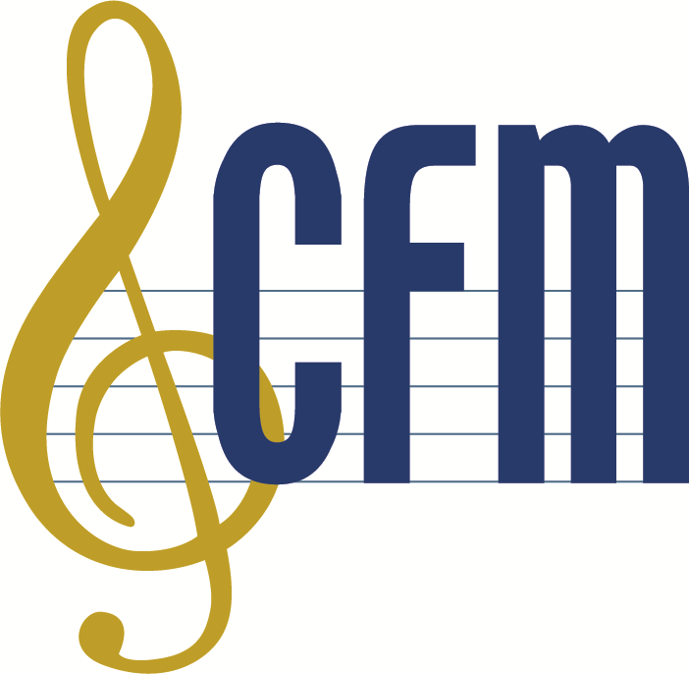
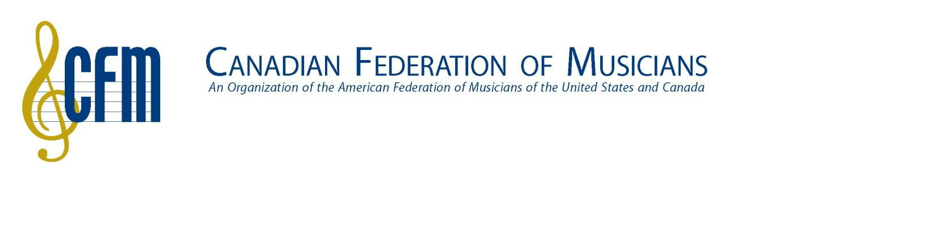

CFM National Office
150 FERRAND DRIVE, SUITE 202 TORONTO, ONTARIO M3C 3E5
416) 391-5161 • 1-800-463-6333
FAX (416) 391-5165

EXHIBIT C

General Agreement for Commercial Announcements (Canada)
TRI-PARTY ASSUMPTION AGREEMENT
(Note: This Agreement to be in effect must be completed fully and executed by all three parties)

The undersigned Transferee of the commercial announcement(s) identified below, acknowledges to the Transferor, that such production and the use thereof is/are subject to the terms and conditions of the Canadian Federation of Musicians’ (“CFM” or “AFM”) General Agreement for Commercial Announcements (Canada) (Apri1 1, 2015 – March 31, 2020), a copy of which said Transferee has read and with which the Transferee is acquainted. The Transferee hereby agrees expressly for the benefit of the CFM, and of the persons covered by the above-referenced Agreement with respect to such television, radio or Digital Media productions, to abide by and perform the provisions of said Agreement and, without limitation of the foregoing, to make the payments for the use, re-use or new use of said commercial announcements required thereby. It is expressly agreed that the CFM, on its own behalf, and on behalf of the persons covered by said Agreement, in addition to any other rights and remedies available to it in the event of breach of this Agreement by the Transferee, shall be entitled to injunctive relief for the enforcement of this Agreement.

Please identify the Commercial Announcement Production(s) and respective AFM Contract number(s):

⎯⎯⎯⎯⎯⎯⎯⎯⎯⎯⎯⎯⎯⎯⎯⎯⎯ ⎯⎯⎯⎯⎯⎯⎯⎯⎯⎯⎯⎯⎯⎯⎯⎯⎯
AFM Contract #
AFM Contract #
AFM Contract #

⎯⎯⎯⎯⎯⎯⎯⎯⎯⎯⎯⎯⎯⎯⎯⎯⎯
⎯⎯⎯⎯⎯⎯⎯⎯⎯⎯⎯⎯⎯⎯⎯⎯⎯

⎯⎯⎯⎯⎯⎯⎯⎯⎯⎯⎯⎯⎯⎯⎯⎯⎯ ⎯⎯⎯⎯⎯⎯⎯⎯⎯⎯⎯⎯⎯⎯⎯⎯⎯
Note: if necessary, continue this list on a separate page or on back of this page.
⎯ ⎯ ⎯

Transferor (person/company making the transfer) agrees to be bound by the terms hereunder: | → | Transferee (person/company to whom transfer is made) agrees to be bound by the terms hereunder:
Name of Signing Authority (print): Authorized Signature:  Date: |  | Name of Signing Authority (print): Authorized Signature:  Date:
Company Name: |  | Company Name:
Address: |  | Address:
Telephone: |  | Telephone:

CFM acknowledges and accepts the transfer of “rights” by its authorized representative  N⎯am⎯e (⎯plea⎯se p⎯rin⎯t) ⎯⎯⎯⎯⎯⎯⎯  ⎯⎯⎯⎯⎯⎯⎯⎯⎯⎯⎯⎯⎯  Signature | Note: This box is to be completed by CFM  Copy forwarded to all parties named hereunder and to;  Local ⎯⎯⎯⎯,  to the attention of ⎯⎯⎯⎯⎯⎯⎯⎯⎯⎯⎯⎯⎯  by ⎯⎯⎯⎯⎯⎯⎯⎯⎯⎯⎯ ⎯ ⎯ ⎯  mm dd yy

REV 10/18

